<SW dEVELOPMENT FOR REFRESHMENTS>

Project Charter

Project Area: Management Reporting and Business Intelligence

Document History

|  |  |  |  |
| --- | --- | --- | --- |
| Date | Document Version | Revision Description | Author |
| Jan 18th, 2021 | 0.1 | Initial | Yong Seung Rho |
|  |  |  |  |
|  |  |  |  |
|  |  |  |  |
|  |  |  |  |

Approvals

|  |  |  |  |
| --- | --- | --- | --- |
| Approval Date | Approved Version | Approver Role | Approver |
|  |  |  |  |
|  |  |  |  |
|  |  |  |  |
|  |  |  |  |
|  |  |  |  |

Table of Contents

1. Executive summary* 3

2. background 3

2.1. Current Situation & Problem Statement 3

2.2. Effects of Not Doing This Project 3

3. goals and objectives* 3

4. approach* 4

4.1. Solution Overview 4

4.2. Impacts on or users and members 4

5. Scope & Deliverables* 4

5.1. Scope 4

5.2. Deliverables 4

5.3. Estimated Timeline* 5

6. Project team Organization* 5

6.1. Roles & Responsibilities 6

7. Project Risks & Assumptions* 6

Assumptions and Constraints 6

8. APPENDIX 6

# Executive summary*

Many business owners want to get information by categories based on collected data to increase revenue and to reduce cost. This project shows interactive charts of sales about refreshments on the west coast of the US on the web. Managers can use these charts for making decisions that can have effects on the business activities of the company.

# Background*

## Current Situation & Problem Statement

The report in the last semester cannot give users detailed analysis or status because it has only static views about overall analysis by categories.

* The previous report is a file or pieces of paper, so it is inconvenient to use when users move.
* It does not have information by month or year.
* It does not have information about stores of cities.
* It does not have categorized information such as cities, stores, and products.

## Effects of Not Doing This Project

This project will give users visual information and suggestion, but a certain decision should be made by users.

# goals and objectives*

The goals of this project are as follows. Managers, users, or faculties can get analyzed information with interactive charts for obtaining revenue and profit and reducing cost. Reporters or students can practice what they studied last semester and test what they will learn in winter semester. Each goal is below.

For users,

* Provide detailed charts on the web.
* Find sales trends by product, customer, or region.
* Find products that generate the most and the worst revenue.
* Find the proper location for a warehouse to be moved or built.

**For members,**

* Learn about how to use chart libs for python.
* Learn about using a web framework for python.
* Practice HTML that we will learn in the Winter semester.
* Time and project management.

# approach*

## Solution Overview

Through this project, users can easily understand information that they want to compare, use this to promote products to increase revenue, and help to find a new warehouse.

## Impacts on users and members

Users can obtain relevant information from raw data to make decisions. Members who join this project can get more confidence to use python and HTML.

# Scope & Deliverables*

## Scope

The scope of this project is as follows.

* Deliver additional information on the previous report.
* Give revenue information about a specific month with hover functionality.
* Give detailed information by categories such as cities, stores, and products.
* Give mobility that users can see on the web.

## Deliverables

|  |  |  |  |  |
| --- | --- | --- | --- | --- |
| # | Project Phase | Milestones, Planning Deliverables | Target  Completion Date | Approver |
|  | Initiation | Discovery  Project Charter | Jan 22nd |  |
|  | Planning | Project Plan  Communication Strategy/Plan | Jan 29th |  |
|  | Requirements | Business Requirements ay also include Service or Product Requirements | Feb 5th |  |
|  | Analysis & Design | Functional Designs  May also include Service, Product and Technical Designs  Test Plan | Feb 12th |  |
|  | Development | Tech Designs & Development  May also include System or Service Network, Server, 3rd Party Service Integration, Service Page | Mar 19th |  |
|  | Testing | Test Plans / Test Cases | Mar 25th |  |
|  | Project Close | Project Close Docs  Lessons Learned | Apr 2nd |  |

## Estimated Timeline*

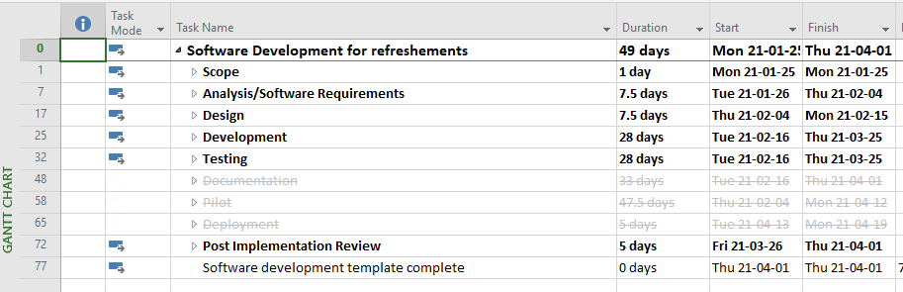

# Project team Organization*

## Roles & Responsibilities

|  |  |  |
| --- | --- | --- |
| Role Name | Name | General Responsibilities |
| Project Manager |  | Schedule Management, Requirement, Deliverables, Documentation |
| Web Developer | Chanhyo Kim | Building a web server, Making web pages |
| Chart Developer | Yong Seung Rho | Choosing a chart solution, Implementing charts |
| Test Analyst |  | Testing web site. |

# Project Risks & Assumptions*

|  |  |  |  |
| --- | --- | --- | --- |
| # | Risk Description | Severity | Mitigation Plan |
| 1 | Choose a chart solution to meet the requirement | Medium | Research and compare solutions before Analysis & Design phrase |
| 2 | Unfamiliar with web and python programming | High | Study and practice Individually. |
|  |  |  |  |
|  |  |  |  |

# APPENDIX